How to add Gateway Optimist Club as your Community Rewards recipient on King Soopers purchases
- On a computer
  - Go to kingsoopers.com
  - Sign into your account
    - If you do or do not have a King Soopers plus card, you will need to sign up for an online account using your card number or they will give you a virtual number
    - To create a new account, Click Sign In and Click Create Account
  - Click My Account under Sign In
  - Click Community Rewards
  - Click Change Organization and search Gateway Optimist Club
  - Click Enroll for the Optimist Club-Aurora, Gateway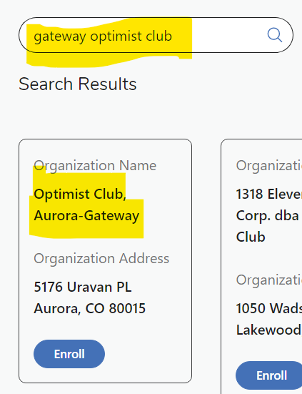
- On the app
  - Sign into your account
  - Click on the 3 Lines on the top left
  - Click Rewards
  - Click Community rewards
  - Click Change Organization
  - Click Change Organization and search Gateway Optimist Club
  - Click Enroll for the Optimist Club-Aurora, Gateway

